**API DOCUMENTATION**

DHAMIS API

GET Data – Outline on sections to pull data from in DHAMIS

Cohort Survival Analysis, Supervision Main Report, Clinical Staff, HTC Providers, Action Points, List of Quarters, Stock Report

**ON PUBLIC IP**

Get Cohort Survival Analysis by facility id

http://<URL>:81/api/cohortsurvival/a4595012/213,10

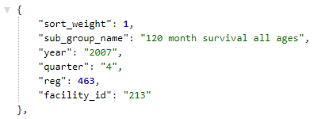

Get Supervision Main Report data by facility id

http://<URL>:81/api/mainreport/a4595012/213,10

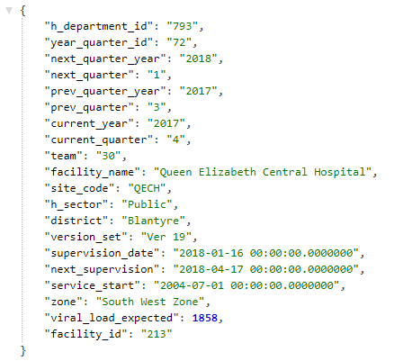

Get Contactable Clinical Staff by facility id

http://<URL>:81/api/clinicstaff/a4595012/213,10

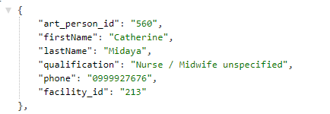

Get HTC providers by facility id

http://<URL>:81/api/htcproviders/a4595012/213,10

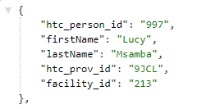

Get Previous Quarter Action Points by facility id

http://<URL>:81/api/actionpoints/a4595012/213,10

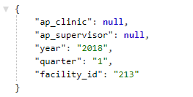

Get current year Quarters list

http://<URL>:81/api/quarters/a4595012

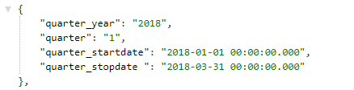

Get previous quarter stock report by facility id

http://<URL>:81/api/stockreport/a4595012/10,213

